**Process Report – Experts in Teamwork**

**TKP4852 - CO2 Capture**

**Transportation 2 – Duckweed**

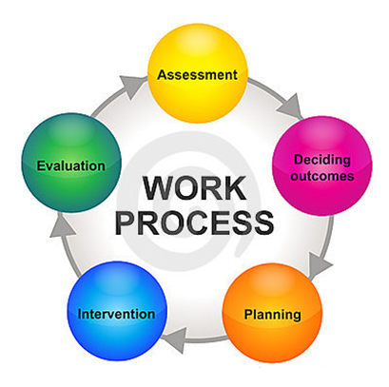

**Erik Gracey**

**Pedro Rondón**

**Peter Skjerstad**

**Rasa Nazarpour**

**Ida Christiansen**

Preface

This project was given by Norwegian University of Science and Technology (NTNU), Faculty of Natural Sciences and Technology, Department of Chemical Engineering. The project was conducted during Experts in Teamwork, in the village TKP4852 - CO2 Capture. The work was performed in the period from 16th of January until 2nd of May.

Thank you to our village supervisor Hanna Knuutila for advice during the process, and to our teaching assistants Gayan Eric Waidyanatha and Anastacia Elisabeth Rainerinty Aaltonen for facilitating and helpful guidance.

NTNU, Trondheim, 02.05.13

*___(Signature)____ ___(Signature)____ ___(Signature)____*

Ida Christiansen Peter Skjerstad Erik Gracey

*___(Signature)____ ___(Signature)____*

Pedro Rondon Rasa Nazarpour

Abstract

This project was conducted during Experts in Teamwork. The purpose of this process report is to describe the process and group development throughout the semester.

Our group consisted of five members, Ida, Peter, Pedro, Rasa and Erik, who all had different professional background, and came from various countries with different cultures. Because of this, our group had some difficulties with communication in the beginning, but during the process we learned that challenges such as these should be addressed as soon as possible, in order to increase efficiency in the team.

A cooperation agreement was made to ensure that the project would be carried out in the best way. We also relied on a time schedule in order to do the project tasks on time. However, our team understood that these would probably be modified towards the end of the project as new variables and situations appeared. In this sense, adaptation was key for the development of this project and the achievement of a desired result.

During the village days the facilitators gave us different tasks that helped us in understanding how our group functioned in terms of communication and working together. We believe these activities accelerated the learning process and contributed to ease the process of team building and development.

Our team acknowledges that working in teams is about assessing and adjusting oneself to the situations that the team confronts at any time. One of the main goals of the group was to come up with an innovative idea that could win us the prize at the Technoport conference. In order to achieve this, the member had to be able to trust each other and have the confidence to speak up. We managed to get to the finals in Technoport, and this was a confirmation that we had a good project.

Our team is aware of the evolutionary process of team building, which seems to follow a clear path from its composition until its dissolution. Thus, our team is sure that learning experiences such as Experts in Teamwork will be useful and affect the way we behave when working in collaboration with others in the future.

Table of Contents

Preface I

Abstract II

Table of Contents III

1 Introduction 1

2 Competence and Expectations 2

2.1 Professional Background 2

2.2 Interdisciplinary Collaboration 3

2.2.1 Competence Triangle 4

2.3 Diversities in the Group 5

2.4 Expectations and First Impressions 6

3 Group Dynamics and Team Development 11

3.1 Different Roles 11

3.2 Decision Making, Work Distribution and Structure 12

3.3 Communication 14

3.3.1 Sociogram 14

3.3.2 Addressing Issues 15

4 Evaluation 17

4.1 Cooperation Agreement 17

4.2 Individual Reflection 19

4.3 Group Reflection 22

5 References 25

Appendix A - Cooperation Agreement A

Appendix B – Work Breakdown Structure B

Appendix C – Activity Network C

Appendix D – Tentative Schedule D

# Introduction

This report describes the process our group went through during Experts in Teamwork. The purpose of Experts in Teamwork as stated by NTNU: *“Experts in Teamwork is a course in which students apply their academic competence in interdisciplinary project work to learn teamwork skills to prepare them for working life”* [1].

This process report describes professional background, expectations and first impressions that every group member had prior to this course. The report also explains how the group developed, with the use of exercises and facilitation.

At the end of each village day personal and group reflections were written down. This report is primarily based on these reflections, as well as theory from the Experts in Teamwork compendium and some other sources.

Our team tried to use the SITRA-model for writing this report. This approach helped to increase the insights and quality from our reflections. The SITRA-model states how important it is to evaluate different situations against literature in order to reflect and take a correct course of action.

# Competence and Expectations

This chapter describes the group members’ background and reflections on how it is to work in an interdisciplinary group. Diversities in the group have also been looked at, along with each member’s expectations and first impression.

## Professional Background

It is important for a group to map out the members professional background, so that they can be used to their full potential. As Johnson & Johnson (2006) states, there are some disadvantages to a group that is too homogeneous. The perspectives of a group in which the members have closely related backgrounds, can be too similar. This can lead to very narrow-minded decisions. Thus, it may create a situation that is not very creative since the members only look at the situation from one perspective [2]. To see if the professional background of the group members were similar or not, they are all presented in the following sections.

**Ida (25)** is currently undergoing her master degree in Chemical Engineering. She has a bachelor degree in chemistry from Sør-Trøndelag University College (HiST) where she gained experience in writing reports, which she could use in this project. Ida has a certificate of apprenticeship in laboratory work, where she worked in groups to solve tasks and problems. This could also benefit the group in the sense that she has been in a similar situation before.

**Rasa (25)** is also undergoing his master degree in Chemical Engineering. He has been studying chemistry since high school and has worked in a lot of laboratories. Rasa has a bachelor degree in Applied Chemical Industries, and during this time he was head figure of board of directors in a chemistry scientific association. Before coming to Norway he was also teaching chemistry at high schools and pre-universities.

**Peter (27)** is undergoing his master degree in Materials Technology. Most of his studies have been directed towards the offshore industry, and includes topics like corrosion, material science, tribology and surface protection. Before starting his two years master degree, he took a bachelor degree in Materials Technology from Sør-Trøndelag University College (HiST), and from writing his bachelor thesis he gained experience in technical report writing.

**Pedro (26)** is currently studying his master degree in Project Management. Project management combines the science and art of running projects, which he can apply to the organization of work and tasks of this course. He has a bachelor degree in Production Engineering, and during his studies he spent nine months in Finland as an exchange student. He worked at a consultancy firm in market research for almost two years. He has always been involved in multicultural environments both during his studies overseas and at work.

**Erik (27)** is an MSc candidate in Industrial Ecology at NTNU. He holds a Bachelor of Arts in International Business from Pacific Lutheran University in Tacoma, and also an Associate of Science Degree in Atmospheric Sciences from Bellevue College in Seattle. He started his professional career as a market analyst in 2008, where he performed market analysis and feasibility studies, which could be useful in this project.

As stated above, all of us had different technical backgrounds. Pedro and Erik had experience with project management and Life Cycle Assessments (LCA), which we actually used to a great extent in our project. Without this knowledge, the project would probably become less complex and not as well executed. Peter, Ida and Rasa had experience with writing technical reports, and were able to contribute giving a technical perspective to the project. Since our backgrounds to some extent, were diverse our team was able to create a broader spectrum of ideas when we needed to come up with technical solutions. In fact, when brainstorming for the initial idea of the project, we seemed to be stuck inside the boundaries of CO2-capture. However, Erik’s industrial ecology perspective helped us to think outside the box, and select a topic which resulted to be rather different from our initial idea. If Erik’s background had been more similar to the rest of us, this project would probably been about some technical aspect to the carbon capture technology.

## Interdisciplinary Collaboration

Since our professional backgrounds were somewhat different, it offered some challenges for the group to work together. None of us had worked in interdisciplinary courses before and therefore not used to working with persons with different backgrounds. However, we all realized that this would be a learning experience, and that the group could use this to its advantage.

A group can benefit from an interdisciplinary collaboration because it is easier to solve a complex problem if there are multiple insights, rather than just one. It is possible for the group members to learn from each other, and understand new ways of thinking [3]. We feel that this was very much the case in our group. From Erik we learned about LCA, which was another way of thinking for the rest of us. Pedro taught us how to be structured when planning the project, with his nice Gantt scheme and project plan (as seen in appendix B, C and D). We also learned from each other on a more social level. From Rasa we learned a new way of thinking based on his culture, since Iran is a lot different from Norway, USA and Venezuela in many ways. We feel that we have been empowered with new knowledge after conducting this course.

However, every person has both technical and social abilities, which build their own perspective to the world. In this sense, we should also consider and acknowledge that these soft skills play an important role. In fact, interdisciplinarity occurs not only when members from different backgrounds work together across borders, but also as a consequence of various personalities. The next section investigates this further.

### Competence Triangle

Since our professional backgrounds were quite different it was necessary to map out our theoretical knowledge, job related skills and personal competence. The mapping helped us to produce a framework for the project that everyone was comfortable with. These results are shown in figure 1.

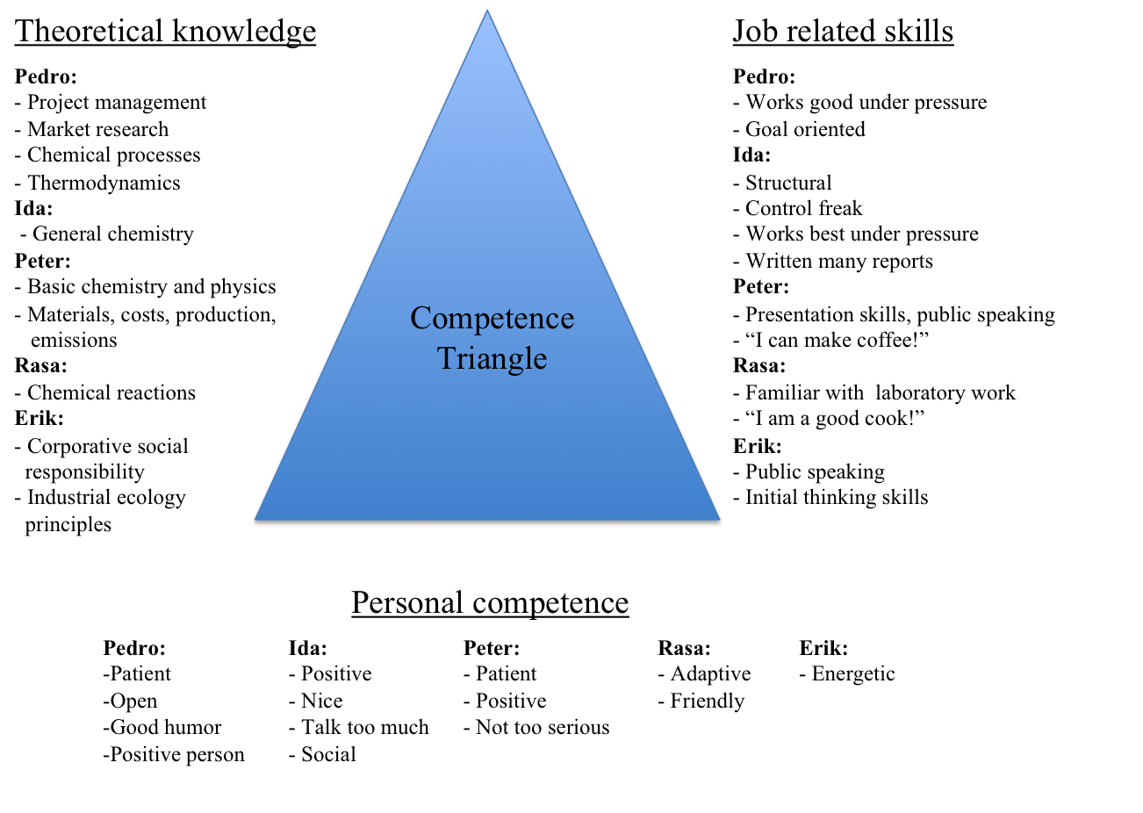

*Figure 1* *Competence triangle with theoretical knowledge, job related skills and personal competence of each group member*

From the figure it is clear that we had a lot of similar competences when it came to all three categories, which could mean that we would work well together as a team. However, it could lead to us not being able to solve a problem because we had similar ways of thinking. The competence triangle also shows that there are some differences within the group, which probably helped us during the process.

The competence triangle made it easy to map out what tasks the different team members would be comfortable with. For instance Peter and Erik stated that they enjoy public speaking, and as a result they were the ones giving the project presentation in class, and at Technoport.

## Diversities in the Group

In any group there are bound to be some diversities. There can be many sources for these diversities, and as Johnson & Johnson (2006) states, diversity can be beneficial or harmful in many different ways [2]. In this chapter we have decided to focus on the ones that we feel are relevant to our group.

In this group we had three main diversities:

1. We came from different cultures
2. We had different professional backgrounds
3. The group consisted of one girl and four guys

The group consisted of five people with four different cultures. Ida and Peter from Norway, Pedro from Venezuela, Rasa from Iran and Erik from USA/Norway. One of the challenges this can lead to, is discussed by Sjøvold (2006), and can be illustrated as an iceberg, shown in figure 2.

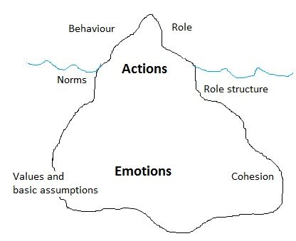

*Figure 2* *Important key points that describe the groups culture, illustrated as an iceberg for analogical purposes.*

The top of the iceberg represents the actions that are visible to the rest of the group. However, the group functionality is strongly influenced by the values and basic assumptions of each member. These emotions cannot be viewed by anyone, unless the person decides to share them. If the emotional issues are disregarded, the group would lose some of its cohesion. Cohesion meaning how attached the team members are to the project and each other [4]. The different cultures can contribute to an uncertainty in the values and emotions of each member. As figure 2 illustrates, these values cannot be understood unless the group openly share their values and way of seeing things.

A particular episode happened when Rasa addressed the rest of the group and said that English was his 6th language. Therefore, he felt that the communications skills of the rest of the group members exceeded his to a large extent, and he sometimes was unable to follow the discussions. If Rasa had not shared his emotions with the rest of the group, he probably would have felt more detached, since it was hard for the rest of the group to see what he was struggling with. After this episode the group took particular care in order to make sure everyone was following the conversation.

As previously stated, the group learned a lot from each other because of our diversities in professional background, and we feel that the project would have suffered if this was not the case. However, if our knowledge had been more similar, we probably would have chosen a topic more compatible with our background.

The fact that the group consisted of one girl and four guys could have led to a polarity. Ida could have felt that her ideas were not considered, or that she was disregarded during discussions. Conversely, our group looked at every member as important and resourceful. This attitude helped to maintain a positive attitude from all team members till the end of the project.

## Expectations and First Impressions

In order for the group to be able to learn something from this process, our expectations and first impressions of Experts in Teamwork are presented in this chapter.

**Ida**

Prior to attending Experts in Teamwork my expectations to the course were low. I had gotten a lot of negative feedback from friends that previously had taken the course. Also, even though I decided this on my own, I was somewhat skeptical about the fact that I was going to attend an international village, and the challenges that this might bring. I had high expectations to the topic of the village though, which was the reason I decided to choose it.

Although my expectations for Experts in Teamwork were low, I still expected to learn something. This concerned mostly the topic of the village, but also how to work in a group with people I did not know. I was also expecting to become more comfortable with speaking English and learning about different cultures, which was also a reason for me to choose an international village.

My first impression of Experts in Teamwork was mixed. I found the topic very interesting, which I also expected. However, I did not get to form the group I wanted, which I had gotten the impression that I could. This was a big disappointment at the time, but after talking to the members of my group and got to know them a bit, I was excited again. It seemed that the group would work well together, and that we would create a good product.

**Peter**

Coming in to the Experts in Teamwork I did not quite know what to expect. Students that had taken the course earlier had mixed reviews. I was advised by many students to keep out of the English speaking villages, since many had bad experiences with the English writing and communication skills of some of the foreign students. It was also said that foreigners only get a pass/fail grade in the course and they therefore contribute less. Regardless of this, I thought the topics of the English villages seemed much more interesting, and I thought it would be nice to get to know more people from other parts of the world. I also felt that it had been too long since I had practiced speaking English, and I wanted to refresh my own communication skills as well.

I figured I would lower my hopes of achieving a good grade and look at Experts in Teamwork as a nice way to get to know different types of people, and hopefully learn something about working with a diverse group. At lunchtime we were told that we would assemble groups after the break, so I had lunch with a nice bunch of people and we figured we could try to make a group. But too many wanted the same topic as us, and we were divided into two groups, with about half of us on each group. Still I thought that the new team members that arrived in the group seemed very interesting and nice, so I was very positive to my group from the start.

I thought that the diversity of the group members would make this project different from all other projects I have attended. My first thoughts of the group was also that they seemed way more motivated and serious than what I had been foretold, so as long as we could find an interesting topic, I knew I would be motivated to put a lot of effort into this course. I never worried that my background would not fit into the group, and I was also very pleased that Pedro had a background from Project Management, which I thought would come in handy at some point.

**Pedro**

In the autumn semester I heard several times that Experts in Teamwork was a waste of time, and I was advised to apply for an exemption if I could. However, my application for exemption was denied, regardless of my working experience and time as an exchange student.

The good thing at least was that I was assigned to one of the villages I was particularly interested in. My expectations for this course were:

* Be more efficient when working in teams
* Learn about climate change issues and possible solutions
* To have fun

When selecting groups, it was evident that that three Norwegians and two guys from USA/New Zealand wanted to form a group. They seemed disappointed when Hanna said that we had to split into two groups, and draw lots to decide who is in which group. I frankly did not like that they did not want to integrate with the rest of the people that had chosen transportation. Apart from that, and after the rest of day went by, I have to say that the first day of work was very good for me. It seems that I was going to work with nice people after all, which was one of my first concerns.

My group consisted of five persons and all of them seemed to be friendly. However, they seemed to have more knowledge than I had regarding CO2 capture. I thought I had to research a lot to be at the same level as them if I wanted to influence them with my opinions. That scared me a little bit, and even made me think “why did I choose this village, if I do not have anything to contribute with”.

I could also see that this project would take a lot of time, but it also forced me to think outside the box. Since the beginning, I felt full of energy and positivity. I wanted to spread this feeling around and make my group become one of the best one. This was for sure an opportunity to put in practice the “art” part (and maybe the “science”) of project management.

**Rasa**

Before starting the Experts in Teamwork course I was really worried about many things. I had never worked like this in a group, and especially since it was in English and I had never been in an English environment before. Like Ida, I had also gotten some negative feedback from last year students, and they told me that it would take much of my time. They also told me that it was hard to write every day reflections about situations that occur. Although Experts in Teamwork suggest that you should choose a village that is different from what you are studying, I chose CO2 capture. This was because I wanted to contribute with the previous knowledge I had.

My expectations to Experts in Teamwork was that I would learn a lot on how to work in groups and learn more about myself. I hoped to meet new people and improve my English, since I have had little experience with English environments.

My first impression was that the topic seemed to be very interesting. Also, my group seemed to work well together, and when we came up with the topic of our project, I was very excited.

**Erik**

I applied for an exemption from the course because I have been working in teams my entire life. I have completed my bachelor degree in Business Administration, which was very team oriented. I did not get the exemption however, and then I started to research the course. I heard from many of my classmates that Experts in Team was a waste of time and that if I was going to take the course, I should choose a Norwegian village to avoid foreigners with lackluster English skills. I initially wanted the Frøya village in Norwegian, but ended up with my 2nd choice, CO2 capture.

I knew a little bit about the topic from my studies here at NTNU, but I did not really know what to expect. The available material online did not give me a great picture of how the class would look or what was expected of me. I went into this first class with an open mind because in my 27 years, I have learned that preconceived notions are rarely beneficial.

I was placed into Transportation 2 by Hanna, which seemed like a pretty cool group. I thought we had a good mix of backgrounds in the group and we were quickly able to come up with some interesting ideas for the project. One aspect of group dynamics that is hard to classify is the “feeling” one has when starting up a new group. This is akin to the chemistry people describe when meeting someone for the first time. I had a good feeling about our group. Ideas were being generated, evaluated, and discussed openly which is extremely important. The course itself was a bit of a mystery to me in the beginning. I did not feel that I had a good grasp of what was to be expected of me, but over time this became clearer.

**General conclusions on initial expectations**

As seen above, there was a general feeling of rejection towards this course before it started. Actually, every team member was skeptical to some extent to the fact that they had to work with people they did not know from before. To some extent, there were culture and language skills prejudice at the beginning too. However, these prejudices were left behind after the team members met and talked to each other for the first time.

After the first group meeting, the expectations from the group seemed to be very high in general. All members had somewhat the same general objectives towards what a good outcome from the group would be.

# Group Dynamics and Team Development

In this chapter a description of the group dynamics and how it developed, is presented. We look at different roles in our group, how decisions were made, how the work was distributed and what management structure our group had. We also look a lot into communication, and how different facilitations given by the teaching assistants helped us to improve the communication within the group.

## Different Roles

At the beginning of the process, we decided to not delegate roles for the group members. We did not know each other, and it was therefore difficult to know which role that was suitable for each member. Instead we decided that we should switch on having the role as secretary. This was to divide the workload equally, but also so that everyone would get some experience in writing the group reflections, since none of us had done something like that before.

Our decision to not divide roles may have affected the effectiveness of the group. As Schwarz (2002) states, an effective group consists of members with clear roles [5]. Since our group chose not to do this, it may have led to us being more ineffective than we could have been in the beginning of the process.

Even though formal roles were not set at the start, informal roles developed naturally as the semester proceeded. Erik rose up to become the leader in the sense that he was the one to speak up. As the other guys wanted to write about all of the interesting information that we found, Ida was the one that reminded the others to keep within our plan, and that we did not have that much time to finish the project. She was sort of the red line that held the other guys on the path. Pedro made a very structured time schedule that we could follow, whereas Rasa had a very rational way of seeing things. This rationality was very important for the group in the brain storming phase, and made it possible to come up with an idea that could be implemented in a real life scenario. After we finally decided on the project description, Peter was able to quickly find some good technical reports on the subject so that everyone was able to get good theoretical insight from the start. This made it possible to somewhat make up for the slow start we had. The development of the informal roles was not all that clear to us, and we were misled to believe that we had a more flat structure than what was actually the case.

One example where it was clear that the group had informal roles, were right before we had to deliver the poster for Technoport. Since Erik had done the LCA, he also took the liberty to check for other possible sources where duckweed could be implemented to reduce CO2-emissions. Erik wanted to implement duckweed-to-animal feed for regions without bioethanol infrastructure. This was a drastic change to our project at a very late state. The result of implementing this was hours of extra work, but Erik was able to convince us that it would be an important change that could drastically improve the reduction impact of CO2, and improve our chances of winning the Technoport conference.

Even though Erik took the leader role in our group, he was open to the rest of the group and never tried to overrule anyone. Instead, all the team members worked together to give a better shape to the raw ideas that Erik proposed. This, in the end resulted to be beneficial and effective as the technical project resulted to be quite robust. Moreover, Erik’s leadership made him take the main control for writing the project in terms of the order and structure that the report should have. Everyone feel their ideas have been implemented and that the overall project belongs to the group as a whole.

Finally, it is also interesting to think what could have happened if Erik would not have been such a charismatic character. Probably, his propositions for changes at latest time would have been rejected by the group, if he had not been able to convince us about the pros that these ideas would bring to the final result. Moreover, none of the team members lowered their motivation towards the project, which shows a good sign of effective leadership.

## Decision Making, Work Distribution and Structure

During the second village day we created a cooperation agreement on the request of our village supervisor. In this agreement we included points about delivery, satisfaction and learning. The cooperation agreement is found in appendix A. Heathfield (2013) highlights the importance of setting norms at the beginning to ensure team success. Norms are important to shape the interaction of team members and also to call each other out on behavior that could be negatively affecting the group [6].

As mentioned in the previous chapter, we did not divide the group into different roles, but they rather developed over time. We felt that this was a good situation, since this led to all our opinions being heard, even though this may have also led to us being more ineffective when it came to making decisions. A good example for this was when we made the tower of straws. Our team used longer time than the most of the other groups planning how the tower should be designed, but we managed to finish before all the other and in the end our tower was the second tallest and it was very stable. The group feels that this situation represents our group dynamics. We spend a lot of time to discuss and plan our work, and then after a long decision making process, we worked fairly quickly to implement the ideas.

Wheelan (2009) states that decision making is enhanced when groups outline, in advance, the strategies they will use to solve problems and make decision [7]. So, our strategy was to involve everyone in the process even though it would take more time. Wheelan also says that involving all members in the process is associated with high quality decision making [7]. This idea resulted to be true for our group because, in the end all the team members felt content with the group’s decisions.

In the end we manage to get the work done on time and we feel satisfied with the work that we have done. The reason for this is most likely that all of us worked well together, and that we all got along. We became friends during this process, rather than just five people working together, and we feel that this helped us a lot during the process.

Approximately halfway through the process, Ida suggested that she could take the main responsibility for the process report while the others focused on the technical report. She suggested this because she noticed that time was running by fast, and the group mainly focused on the technical report. Also, she felt that it would create more work for the whole group if everyone were to write on both reports. The technical report was most crucial at that point, but we all agreed that the process report needed to be written at the same time. We also realized that the problem with only Ida writing the process report would be that it would consists of only her reflections. Therefore we decided that Ida would write the first draft, and everyone would proof read it and add some of their own reflections. Also, Ida would use the group reflections while writing, so that previously reflections from the whole group would be included. In the end, this approach resulted to be very efficient for our group, but unfortunately it resulted in fewer reflections. Fewer reflections resulted in less action to improve our cooperation, and the end result is that we could have learned more about our self and group dynamics if this had been implemented.

## Communication

Communication is one of the most important factors in a group, and how well a group communicates is crucial for the project process as well as the final product. Schwarz (2002) states that communication means that information is exchanged so that the sender and receiver understand the meaning in the same way, and only valid information needs to be communicated to achieve an effective group [5]. One of the actions that our team took was to open a WhatsApp Messenger group, in order to have a medium for clear, easy communication between the team members. We used the group as a notice board to schedule meeting, post tasks, important due dates and other relevant information. As a consequence to the implementation of this tool, all the team members felt updated about the latest events and progress, which enhanced the motivation and involvement to a large extent.

During Experts in Teamwork we got to reflect on the communication in our group with exercises given by the facilitators. These exercises are presented in this chapter.

### Sociogram

During one of the village days Gayan gave us a sociogram. This showed the conversations that the group had conducted during a few minutes he had observed us. The sociogram showed how we had interacted with each other and the group as a whole. A sketch of this sociogram is shown in figure 3.

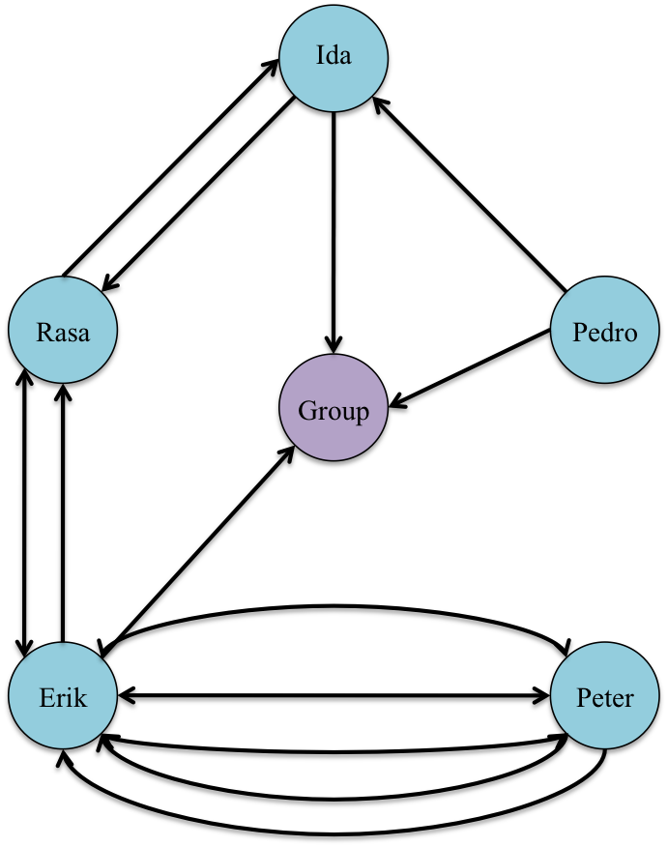

*Figure 3 Sketch of the sociogram*

As seen on figure 3, Erik and Peter talked much more than the others. Peter’s first impression about the group dynamics was that Erik took most charge in the group. However, as the sociogram shows, as soon as Erik stopped talking, Peter took control of the conversation. This corresponds well with the theory from Sjøvold (2006), that as soon as a person is not fulfilling his or her usual role, someone else takes over without even acknowledging this fact [8].

During our reflection about the sociogram, we acknowledged that there was a finite space in our conversations. In that sense whenever a team member decreased his participation in the conversation, immediately the rest of the group would fill that space. To make sure that everyone got to participate in the conversation and share their opinions and ideas, the ones that talked the least got direct questions from the other team members of how they felt about the current topic. This way we made sure that the input from all team members were acknowledged.

The sociogram also showed that there were more conversations between two and two group members, rather than an open communication within the whole group. However, this sociogram described one moment during the whole village day where we had not really started working, and Ida and Pedro were on their computers. Therefore we all agreed upon that it did not reflect on our group dynamics. However, we all felt that we needed to pay more attention to this in order for everyone’s opinion to be heard. As Wheelan (2009) states, ensuring that everyone in the group gets heard can make a big difference in group success and effectiveness [7].

### Addressing Issues

The sociogram that we received from the village facilitator became the group reflection that village day, and it was Rasa’s turn to write it. To get input from the rest of the group, he sent a text asking us to read the reflection before he uploaded it to It’s Learning. It turned out that only Pedro responded to his text, while the rest did not bother for various reasons.

The following village day, Pedro confronted the rest with this situation, and asked us why we did not respond to Rasa’s request. He felt that we did not care enough about the fact that Rasa was not comfortable with writing about the sociogram. Pedro felt that this was a big issue, because in Rasa’s situation, he would have been disappointed of his team members. Rasa said that he did not think that much about it since he had texted us late on a Friday, but that he was a little surprised and disappointed that the group did not respond to his question.

Erik, Peter and Ida all felt very guilty when Pedro assessed this issue, because they all felt that they should have responded, at least during the weekend. All of them were busy when Rasa sent the text, but they all recognized that they should have responded at a later time. Everyone agreed that this was an issue that the group needed to work on, since nobody wanted to be in the position Rasa had been in. Everyone also felt like this issue was serious, and that Pedro had done the right thing by addressing it, even though he knew that it could have created a negative atmosphere.

Schwarz (2002) states that undiscussable issues are issues that the group members feel will create a negative environment in the group, and therefore choose not to address. However, these issues are important for the project process and they are therefore important to discuss. Also, they will not get resolved if they are not addressed. This can lead to a process that is less effective, since these issues are not dealt with. It can also affect the growth and development of individuals and the team as a whole [9]

In order for us to achieve a more open group we all agreed that we would try to become more aware of this particular ground rule. We decided to try to create an environment where everyone would try to have an open mind and where we all could feel comfortable to address such issues if they occurred. After every village day we would all try to answer the question: “What was the best and worst part of the day/week?” In that way this session would not only address negative issues, but also positive things about the day/week.

However, the group failed to implement this idea to our daily routine. After reflecting on why we failed, the general agreement was that all of us felt that the technical report was more important, and that we always wanted to work as much as possible on this issue. Since Ida was the only one engaged in writing the process report, the rest of us did not think much about the importance of addressing issues that could be of benefit for a better understanding about group communication. Ida did not address the fact that we did not follow through on this idea either, mainly because we already had a lot of situations that could be implemented in the process report.

# Evaluation

In this chapter we evaluate the whole process of Experts in Teamwork. We have looked at the cooperation agreement and how we used it in the process. We have also included our personal reflections, where we describe what we have learned and how our impressions have changed during the semester. We have also included a group reflection, where we reflect on how we have worked together as a group, and how the group dynamic has changed during the process.

## Cooperation Agreement

In this chapter we have evaluated the cooperation agreement (appendix A) that we wrote on the second village day. In this chapter we present each point in the agreement to see if we have used and followed it.

The first point in our cooperation agreement states that we all should contribute to writing both the process report and the technical report. This was originally our plan, but as described earlier in this report, we decided that Ida should have the main responsibility for the process report while the others focused most on the technical report. However, everyone wrote their own personal reflection for the process report, as well as finalizing both of the reports together. This decision was very important, since we would have had much less time at the end if everyone should have written both reports. This process report would most likely have been neglected until the two final weeks, and this may have led to a poorer result. However, had all of us contributed more consistently, it would have been easier to implement reflections from the beginning.

In point number two we stated that everyone should attend at agreed time, and that if someone was late they should send an SMS to at least one other group member. We have come to notice that everyone have been late some of the village days, but that everyone have sent a message on WhatsApp to notify the rest. Erik had a course every Wednesday, so he came later than the rest most of the village days. But we all knew that this was the case, and no one had a problem with it. Usually the village days started with a game given by the facilitators, so if someone was late, it did not affect the work on the project. However, sometimes the morning started with a group task, which was affected by people not showing up. Further in point number two we stated that if the same person came late more than twice, the matter should be raised in a discussion meeting. This part of the agreement was never fulfilled, even though several of us were late more than two times. The reason for this was that we felt that it was not crucial for everyone to be present in the beginning of the day, since the morning activities seldom were of importance to the groups’ effectiveness.

The third point in the agreement is about the summary meeting that we decided to have after every village day. This point has been followed through every week, and we have taken turn of writing the minutes of meeting and posting it on It´s Learning. In the summary meeting we included tasks that we were going to do until next village day, and who was responsible for them. We feel that this made it more clear what was expected of everyone, and what we needed to produce every week.

Points number four and five were very easy to follow. We all came along great from the start, and we tried to get to know each other better by socializing outside the village, as well as having fun while working. Sometimes there were too much fun and games during the village days, and this may have gotten in the way of working efficiently during Wednesdays. But we all contributed with work the rest of the week, so we do not feel that this slowed down the process to a large extent.

The sixth point states that if somebody was not feeling well one day they would let everyone know so that the rest could take that into account. Our team did not experience this situation many times. However team members that were tired or had a headache informed the rest of the group of this situation.

Pedro created a process plan in the beginning consisting of a work breakdown structure, activity network and a tentative schedule, seen in appendix B, C and D respectively. This was done to set up milestones as we stated in point seven in the cooperation agreement. This helped us a lot to keep track of our work, and we were able to see how much work we had left. However, we did not manage to follow the plan we had since we wanted to include so much interesting angles in our technical report. We therefore had to make some changes to our milestones, which we had opened for in the cooperation agreement.

In point number eight we stated that we should give each other honest and constructive feedback. As explained in chapter 3.3.2, Pedro openly gave the rest of the group honest criticism. Instead of leading to negativity, as may be assumed, it led to a more positive and open atmosphere.

Point number nine says that we should challenge each other to do tasks we do not feel completely comfortable with. Since the group members had such different backgrounds this rule had to be followed in order to get the project done. Pedro focused on more technical parts that he usually work with, while Peter tried to help with the LCA, and Ida wrote most of the process report. The last point says that everyone should contribute to writing group reflections, and as stated above this was accomplished. Every member wrote group reflections, which was out of our comfort zone,

We feel that this cooperation agreement was useful for this project. We did not use the agreement during the semester, but setting clear boundaries as for what was acceptable behavior made it easier for everyone to adapt to the group. By doing this there was less uncertainty of what was expected of each individual both in behavior and work load.

## Individual Reflection

**Ida**

My final impression of Experts in Teamwork is a lot different from what I was expecting. Previously I almost dreaded this course, but very quickly I realized that it was very interesting and fun. During the semester, I actually looked forward to the Village days every Wednesday.

I feel that this course made me realize some things about myself and how I work in a group. Since we decided early on not to divide the group into defined roles, we took on whatever role that came natural for us. However, I think I would have worked more efficiently have I been given a role with specific tasks.

I personally feel that the group functioned on a social level, and also on a working level, but that we were not efficient enough for the task that we had. I think we all underestimated how much time we needed, to finish the technical report of the project. I think we could have avoided the large workload at the end of the course if we had been more structured in the beginning of the process.

During Experts in Teamwork I was forced to speak English which lead to me becoming more comfortable with the language. I also learned a lot about the different cultures, since our group members came from all around the world. All in all I feel very satisfied with the outcome of Experts in Teamwork, and several of my goals have been fulfilled.

**Peter**

Looking back on Experts in Teamwork, I have had a pleasant experience. It has been a very different course from anything else I have done, and I have learned a lot about both myself and how a group functions. Our topic was very interesting, but for most of us it was a new subject with tasks that we had little or no experience with. Especially the LCA was for me a difficult task where I tried to contribute, but had a hard time really getting any productive figures or numbers that could be used in the report.

Since we had a very flat structure and no precise roles in the group I sometimes found myself in a position where I wanted to get something done on the project, but had no idea where I could contribute. As we started the LCA Erik found a very smart solution of implementing animal feed as a substitute product for bioethanol in areas with no biorefineries or similar infrastructure. This gave us a lot of work to implement in the last weeks, and our planned time schedule of only proof reading the reports the last weeks did not even come close to reality.

The project in itself was so interesting, that I for the first time ever had a feeling that I was working on something original that could actually be implemented into a real life scenario. I was not surprised when we made it to the final round at the Technoport conference, and was actually a bit disappointed that we did not win and got the chance to travel to Brazil to show them our idea.

To sum it up, I found Experts in Teamwork to be very rewarding and fun. We should have been more structured and better at dividing tasks between the weekly sessions. Too much of the technical report was done in the last minute, and we should perhaps have found a topic that we were more comfortable with on a technical level. Even if that would have made it easier, I cannot imagine that we would have found a more interesting topic, and it has been rewarding to learn so much about something I knew so little about.

**Pedro**

Experts in Teamwork has been a very good learning experience for me. From beginning to end, I can say I experienced things that made me a better-rounded team player. In fact, this course has been a revealing experience especially for me, because at the beginning I thought that it was going to be the biggest waste of time at NTNU.

My team made the whole process run smoothly from the first meeting on. Every time we encountered problems or obstacles, we worked together to recognize and to find a solution to overcome them, always with a positive attitude and respecting each other’s points of view.

Our team had students from different academic disciplines and cultures. This fact made me a little cautious at the beginning of the course, but this was a pre-judgment that I could discard quickly and easily. All team members, despite his or her nationality and academic discipline, became a supporting element in our team. Each one of my team members gave a different contribution and our team resulted to be a very balanced and effective one.

The first reason I signed up for this village was that I wanted to know a little bit more about the climate change problem. I personally believe that, with the research that we did, I achieved my objective to the fullest extent.

I am very pleased to have been a part of this wonderful experience. I am very satisfied with the work we have done, and that we got to the finals in Technoport. I feel that this experience was enriching for everyone of my team mates as well.

**Rasa**

By the end of this course I can say that I learned a lot from it. One of the main things that this course taught me was how to adapt myself to work with different people, in order to make the team more efficient and effective. In other words, working in teams is more about changing and examining oneself to be able to understand and weight how these actions affect the effectiveness of the team.

I personally believe that Transportation 2 was a great experience. My team understood at all times how challenging it was for me to write and sometimes to communicate my ideas clearly in English. In this sense, they were patient with me and helpful whenever I needed a hand. We understood at some point that clear, direct and honest communication between the team members is essential if the team wants to success in any task to be undertaken.

I am stunned about how much I learned about myself and about other cultures. Every now and then I witnessed how each team member reacted in a different way to various situations that the team confronted. This, particularly made me understand how important is not to take anything for granted when working in groups.

Finally, in regards to the project, I can say that I am satisfied about the final result and that we managed to reach the top eight projects in Technoport. I am sure the learning experiences I have gotten during this process will affect the way I behave when collaborating with others in the future.

**Erik**

I was skeptical to Experts in Teamwork when I first started the course. Friends had told me that it was a giant waste of time. My experience is Experts in Teamwork has been quite the opposite, which shows that one should not have preconceived notions without doing some homework.

I felt very comfortable with the group from day 1. We were able to communicate very openly with another. This led to a series of brainstorming sessions that bore fruit by improving our team chemistry and starting the development of a topic. The choice of duckweed for a project arose somewhat spontaneously. I put forth the idea during one such brainstorming session and the group responded with sincere interest.

The project took shape without internal conflict in the group and work was assigned organically. The most impressive aspect of the group dynamics in my opinion was the openmindedness and flexibility the group showed. The project took many turns and because increasingly more complex, but we were able to rise to the challenge by openly expressing our concerns, opinions, and ideas. The final product of the technical portion is something that I am very proud of.

We were challenged by Gayan to be excellent and though I had a bit of doubt, we were able to achieve an admirable result by making the finals at technoport. I learned a lot about group dynamics and effective teamwork in this course. Technoport was the highlight of EiT because we were able to present our findings and observe the work of other students. My reflection on this course is very positive and though I admit perhaps being lucky with my group, I will speak highly of this experience to others.

## Group Reflection

From all of our personal reflections, it is clear that we have all learned a lot from this experience. We feel that we worked very well together as a team, and that we managed to solve the problems that occurred. However, we see from our individual reflections that we thought we had a more flat structure, than the actual case. After discussing our group dynamics and reflecting on the subject we feel that each member had a clear role even though it was more informal than formal. Had this fact been acknowledged earlier we could have assigned more formal roles and probably achieved an even better result.

We feel that some of the facilitations during the village days could have been modified to teach us even more about group structure and work. We feel that a lot of the games we had in the beginning of the day were not helping us in the process part of the course. It would have been better for us as a group to get a task that could challenge our cooperation, and teach us how to work together. However, there were some of these tasks as well, like the building straw-towers, which we felt was useful because we had to plan and execute the building together.

When it came to writing this particular report, Ida took the main responsibility as planned. The other guys wrote their own reflections and personal backgrounds, and also helped her at the end, with proof reading and adding some personal reflections to the situations mentioned in the report. This made us think less of reflecting during the sessions and was not the optimal solution. More reflection underway could have been followed by actions to change unwanted features that the group possessed. If this had been done we could have seen how these actions affected the group, and as a result have learned even more about group dynamics.

We feel that after we received the sociogram from Gayan, that we became more aware of everyone’s opinions and thoughts on different subjects. Everyone got to be a part in making decisions about what to include in the project, as well as the poster and presentation at Technoport. This was an important factor for the project becoming as well executed as it was. This is something the group feels proud of. We were able to keep a high cohesion.

The group is very satisfied that we managed to get to the finals in Technoport, and we are satisfied with our project. We agree that the groups’ best feature was that during the discussions on village days all members were heard, and their ideas implemented to the project. Even though we could have achieved an even higher efficiency, the extra time spent discussing important matters, and making sure everybody agreed on important decisions, made all the team members feel a strong bond to both each other and to the project.

Summing up, during the course of this semester, all team members learned to hear and communicate ideas effectively. We also gained knowledge about other useful skills such as: flexibility, sharing and cooperation. We have no doubt that these skills will be have a great importance for our future working life and also for relationships with other people.

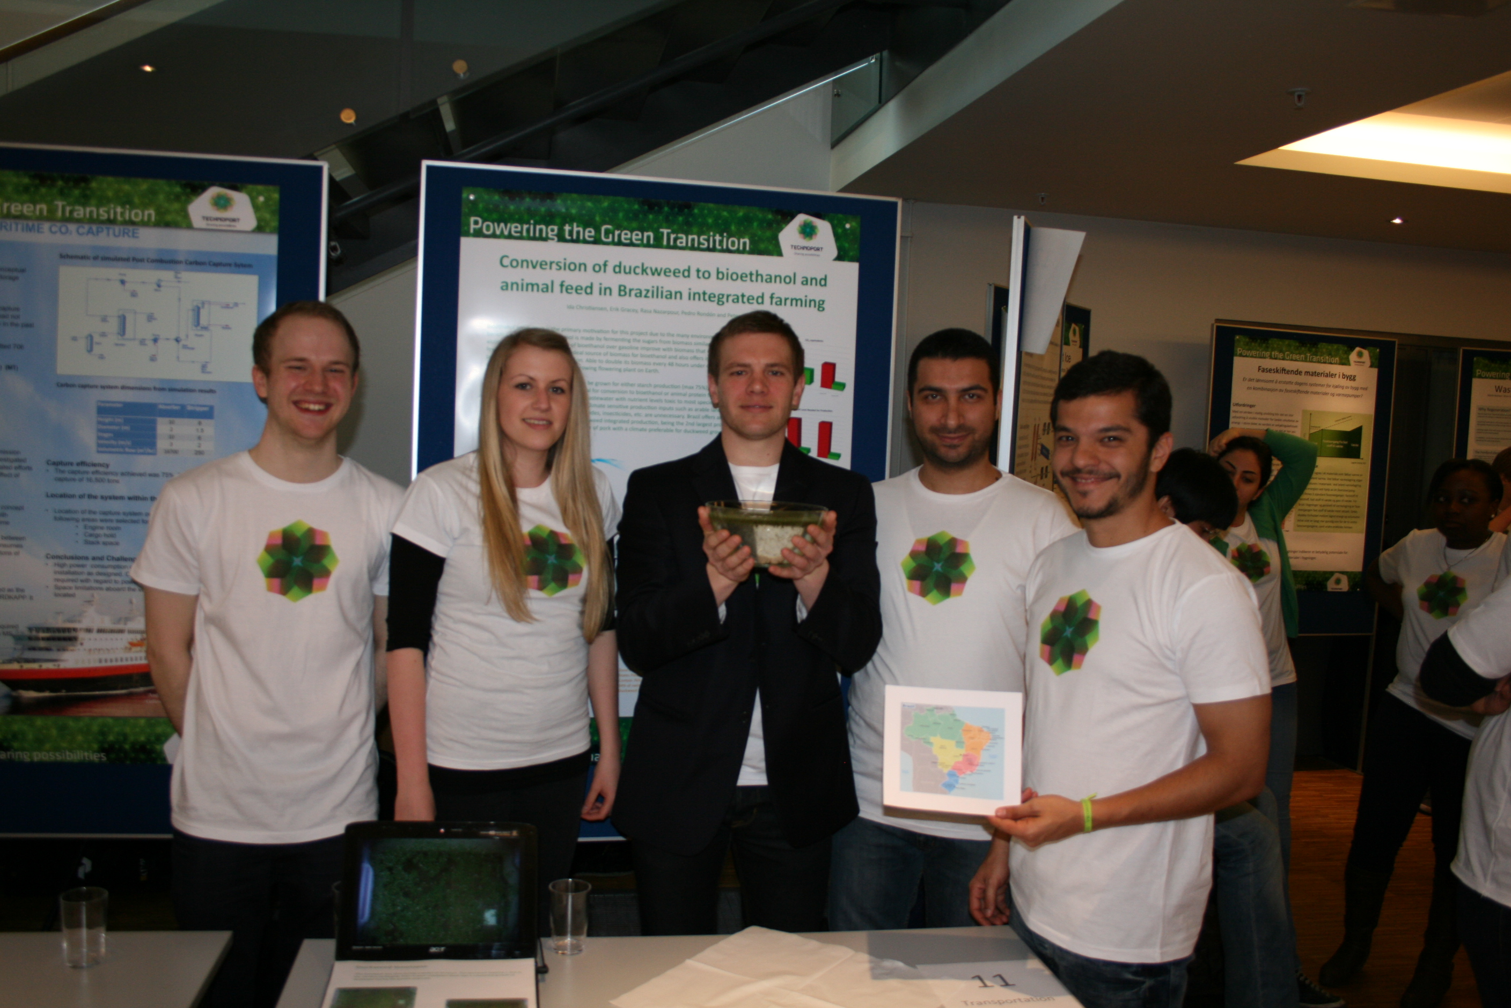

# References

1. Experts in Teamwork, NTNU, 2013. Available from: <http://www.ntnu.edu/eit>. [Cited 02.05.13]
2. Johnson & Johnson (2006) *Joining Together – Group Theory and Group Skills, Chapter 10: Valuing Diversity.* **p**. 441-473

1. Amey, M.J., Brown, D.F. (2004) *Breaking Out of the Box: Interdisciplinary Collaboration and Faculty Work (HC)*. Information Age Publishing. **p**. 1-15
2. Sjøvold, E. (2006) *Teamet:* *Utvikling, effektivitet og endring i grupper. Kapittel 7 Hvordan og horfor tildeles vi vår plass i grupper?.* p.95-106. Universitetsforlaget.
3. Schwarz. *The Skilled Facilitator* (2002) Chapter 2: What Makes Work Groups Effective?. **p**. 17-34.
4. Heathfield, S. (2013) *How and Why to Create Team Norms: Adopting Guidelines for Team Member Relationships*. About.com. Available from: <http://humanresources.about.com/od/teambuilding/qt/norms.htm> [Cited 02.05.13]

1. Wheelan, S.A. (2009). Creating Effective Teams. A Guide for Memebers and Leaders. Chapter 5: Effetive Team Members. **p.** 53-76 Third Edition. SAGE.
2. Sjøvold, E. (2006) *Teamet: Utvikling, effektivitet og endring i grupper. Kapittel 13 Rollestruktur og dynamikk.* p. 166-184. Universitetsforlaget.
3. Schwarz. *The Skilled Facilitatior* (2002) Chapter 5: Ground Rules for Effective Groups. **p**. 129-130

Appendix A - Cooperation Agreement

CO2-capture in transportation section

**Delivery**

1. We agree that everyone must contribute to the work and writing of both the process report and the project report. Everyone shares the responsibility for ensuring that the reports are of such quality that they satisfy the requirements for outstanding performance defined by the course requirements.
2. Everyone attends at the agreed time. This also applies to meetings outside the village days. If you are delayed, send an SMS to at least one of the other group members. If the same person is delayed more than twice, the matter must be raised at a discussion meeting for this purpose in the team.
3. At the end of each village day we will have a summary meeting. Here we will discuss what we have done and task for next week will be established.

**Satisfaction**

1. We will try to be social outside of the project
2. We want to have fun along the way. It is easier to work when there is a good atmosphere and plenty of energy. As a team, we value laughter and good humor.
3. If somebody does not feel well one day, we would like that person to tell us as soon as he or she checks in at the start of the day, so that the rest of us can try to take that into account.
4. We will set up milestones along the way so that we can avoid a heavy workload at the end of the semester. For work satisfaction in the team, it is important that all team members do their part of the work at the agreed time. We will change these milestones as we see fit, during the summary meetings.

**Learning**

1. Everyone must practice giving each other honest and constructive feedback, to give us the greatest possible opportunity.
2. We will challenge each other to take on tasks that we do not feel completely confident about, to learn something new.
3. We will take turns in being responsible for writing the group reflection and reference from the summary meeting, and posting it on It’s Learning.

Signed by:

*___(Signature)____ ___(Signature)____ ___(Signature)____*

Ida Christiansen Peter Skjerstad Erik Gracey

*___(Signature)____ ___(Signature)____*

Pedro Rondon Rasa Nazarpour

Appendix B – Work Breakdown Structure

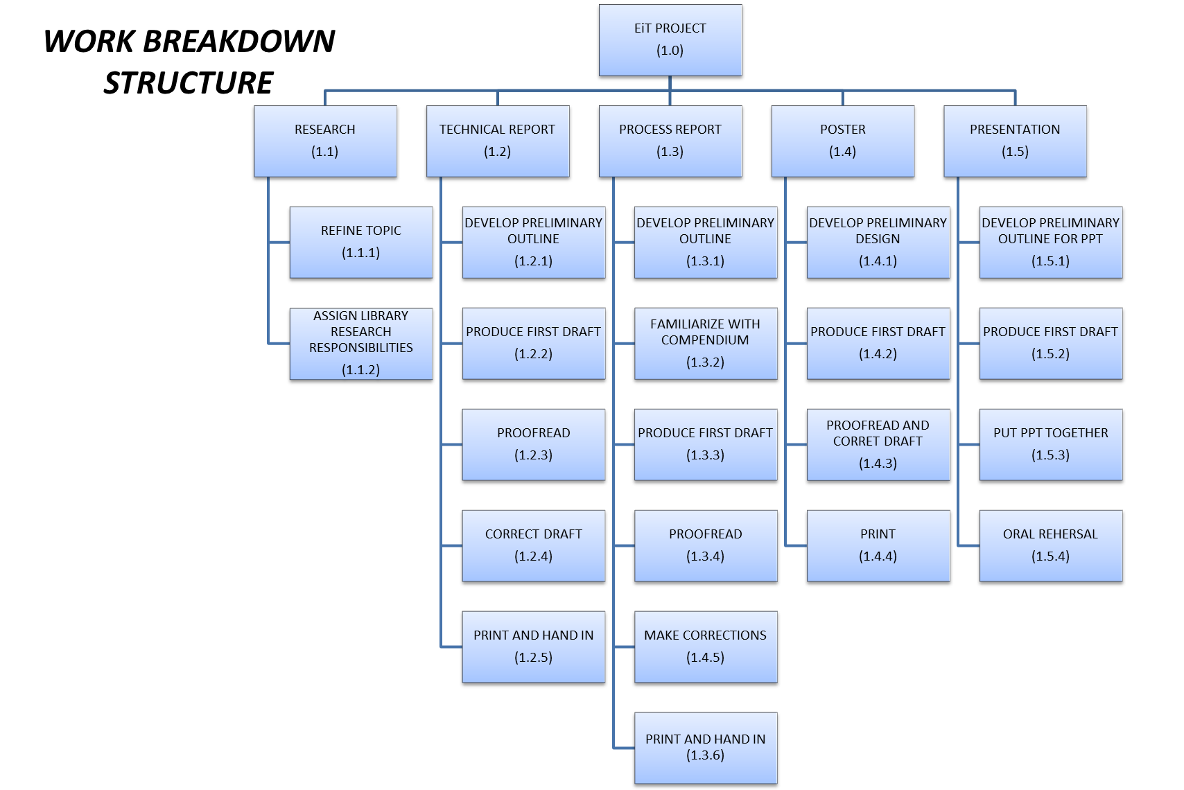

Appendix C – Activity Network

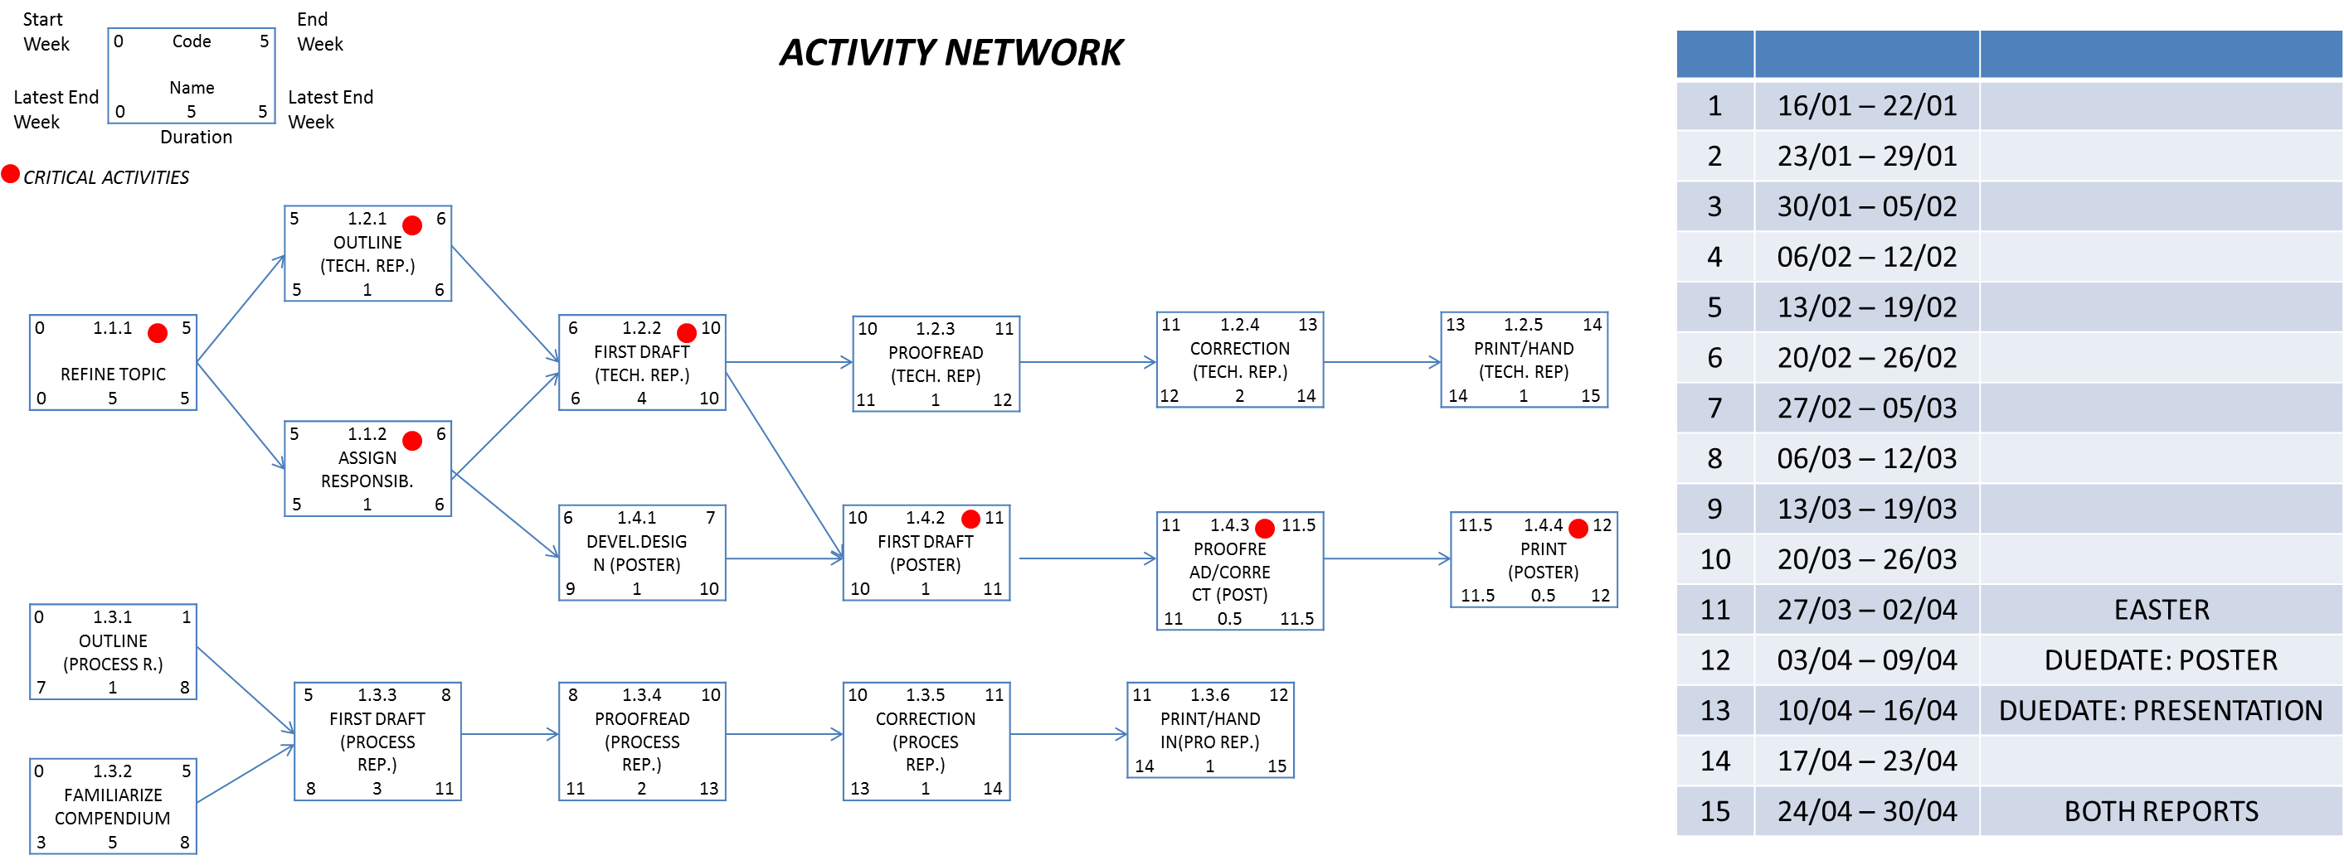

Appendix D – Tentative Schedule

